**TLDR: Binary search (Middle, Middle, O(log(n)).**

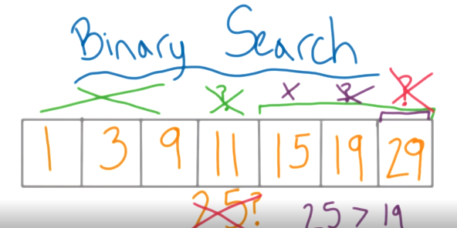**Algorithm:** Tricks to solve a problem

**Q:** How to find number 25 in this stack?

**A:**

**1.Linear search: O(n)**

**2.Binary Search:** O(log(n)+1)( Why Name ? find a postion of binary)

Middle, Middle, Middle.